**Package Managers**

* One way to install software on Linux
* For the user kind of the same as an app store – store with lots of applications you can install, you can select one and it will install it automatically for you
* Package manager can do a lot more: real jobs is to manage dependencies between applications
* On alpine Linux, the package manager is called apk (for alpine packages)
* If you use it for the command search it will show you all available packages
* Apk search | wc -l
  + Wc = word count
  + -l = lines
  + So will show you the number of lines
* One of the main differences between different Linux distributions is the packages they distribute and how they manage it
* The alpine Linux that we’ll be using has a package manager called apk and it distributes files in that format
  + An apk file is basically a zip file with information you need about the file such as what its dependencies are
  + These days in two different formats: .apk (an app you can instal on an android phone) and .apk for alpine Linux package manager
  + For Debian/Ubuntu/Mint use a package manager called apt
* Packages live in repositories
* These used to be distributed on CDs
* Now host on the internet

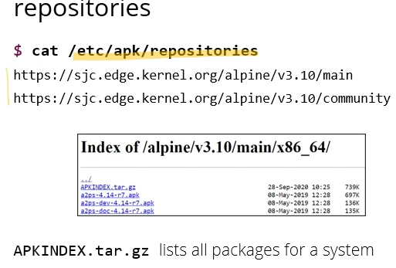

* Apk commands to help find and inspect packages:

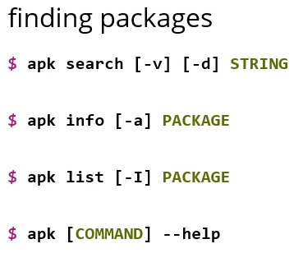

* Apk search looks up a package by name, -v option will display more info about the package apart from just the name, -d will search in the packages description as well as the name
* Once you have a package, apk info will tell you more information, -a option will tell you more information such as dependencies
* Apk list can use to see if packages installed or not: -I option will tell you which packages are currently installed
* To update and upgrade system if managing your own:

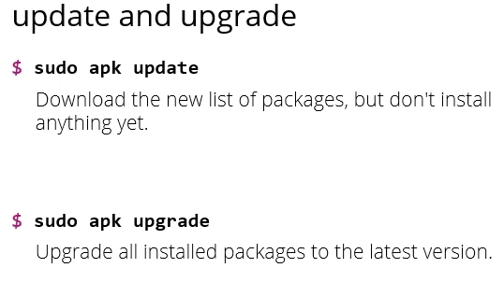

* Update means download new list of packages from server but doesn’t install
* Need to use sudo to act as a super user, as it is a command that changes the system level file where the package is stored
* Upgrade says, based on the previously downloaded version of the package list, fetch every package where the installed version is older than the latest version, and upgrade that
* Update downloads the latest list to your computer, and upgrade compares that list to the ones you have installed & if it finds a newer version of any of them it installs that
* To install a package:

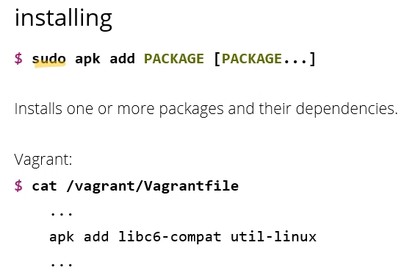

* If you’re running a VM on vagrant (especially if its on a lab machine), the packages you want installed to start with are in the Vagrantfile
  + Vagrantfile will tell you which commands the computer will use when it builds the machine for the first time
  + In the example above, cat prints the file to the terminal
* Sometimes, you have a file and want to know which package is responsible for this file

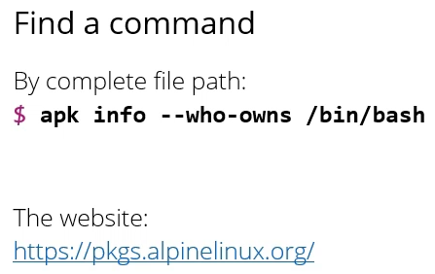

* The apk command for that is info – as seen above
* Any options that are longer that one character you need to prefix with two dashes instead of one